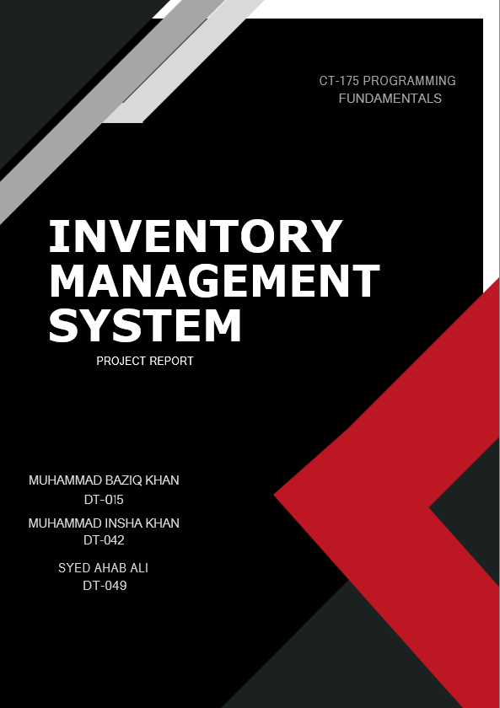
Introduction:
In today's business environment, managing inventory effectively is crucial for the success of any organization. An inventory management system is a software tool that helps organizations to efficiently track and manage their inventory levels, orders, sales, and deliveries. These systems can also be used to generate reports and analyse inventory data, which can provide valuable insights into inventory trends and help organizations make better business decisions.
The purpose of this project report is to design and implement an inventory management system that can be integrated into multiple systems. This report will detail the entire process of the project, including the gathering of requirements, the design of the system, the implementation and testing of the system, and the provision of user training and support. Additionally, the report will include an evaluation of the system's performance and any recommendations for future improvements.
Overall, this project report will provide a comprehensive understanding of the entire process of design, implementation and maintenance of inventory management system and its impact on existing management systems.
Need of An Inventory Management System:
An inventory management system is a crucial component of any business that maintains a physical inventory of goods. It is used to track and manage the flow of goods/products, from the time they are received from suppliers to the time they are sold to customers.
Here are a few reasons why inventory management systems are important for businesses:
- Cost savings:
- Improved customer service
- Increased efficiency
- Better forecasting and planning
- Compliance
Overall, an inventory management system can help businesses save money, improve customer service, increase efficiency, and make better decisions. It can also help businesses comply with regulations and stay competitive in their industry.

Implementation:
In this inventory management system, we used the C programming language along with several of its predefined libraries and implemented several features to improve the efficiency and accuracy of managing inventory.
We used file handling functions of C language such as fopen(), fread(), fwrite(), fseek() and fclose() to read, write and update data from files. This allows the system to store and retrieve product information, such as name, price, quantity, and description, in an organized and efficient manner.
Initially we started with creating a function called gotoxy which basically sets the cursor on the console window on our desired coordinates using the “COORD” structure defined in the windows.h header file.
We used the rand() function to randomly generate an Identification Number for every product added.
We also added search and modify functions that allows users to search for products by their Name or ID and can modify it by their choice. This feature makes it easy for users to find/update the products of their need.
We also added a removeProduct function which basically removes the products of the users need. This function incorporates other features/functions of C language like remove, rename and fseek. To remove a product, the code copies the entire inventory to another file except for the product that has to be removed, deletes the original file and renames the new file with the same name as the original.
We have also used several functions from the windows.h library such as the MessageBox() function to prompt the user at certain instances such as “Account Created Successfully”,”Invalid Credentials” and “Are you sure you want to remove?”.
In addition, we also implemented a login system that prompts users for their username and password, and then compares them to a file or database of stored credentials. This feature provides an added layer of security and ensures that only authorized users can access the system.
Overall, the features we implemented in this inventory management system are designed to improve the efficiency and accuracy of managing inventory for any business or someone who just wants to manage whatever stuff they own.
Algorithm:
The following is the algorithm for this program:
- Create a structure called product to store information about each item in the inventory, including fields for the item name, ID, quantity, price, description, category, and date/time.
- Create a main function that calls the loginSystem() function to authenticate the user.
- Implement the loginSystem() function to check if the user has an account, if not call the createAccount() function.
- Implement the createAccount() function to allow the user to create a new account by entering a username and password, and store the account details in a file using file handling functions.
- After a successful login, call the menu() function to display the main menu with options to add, remove, display, search, and modify products.
- Implement the addProduct() function to allow the user to add a new product to the inventory by filling in the fields of the struct product, such as id, name, price, quantity, description, category, and date/time. Use file handling functions to write the new product information to a file.
- Implement the removeProduct() function to allow the user to remove a product from the inventory by searching for the product by id, then removing it from the file using file handling functions.
- Implement the displayProduct() function to allow the user to display all products in the inventory, by reading the products' information from the file using file handling functions, and displaying them using the displayProduct() function.
- Implement the searchProduct() function to allow the user to search for a product by id or name, by reading the products' information from the file using file handling functions, and displaying the product information using the displayProduct() function if found.
- Implement the modifyProduct() function to allow the user to modify the information of a product by searching for it by id, then reading the product information from the file using file handling functions, updating the fields of the struct product as desired, and then writing the modified product information back to the file using file handling functions.
- Implement the menu() function to allow the user to choose between different options and call the appropriate functions as needed.
- In the main function, open the file that stores the products' information at the beginning of the program and close it at the end of the program to ensure the file is closed properly, and handle any errors that may occur during file handling operations.
Screenshots:
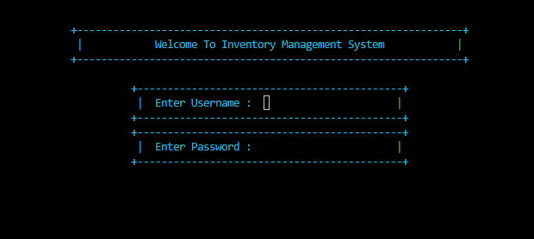
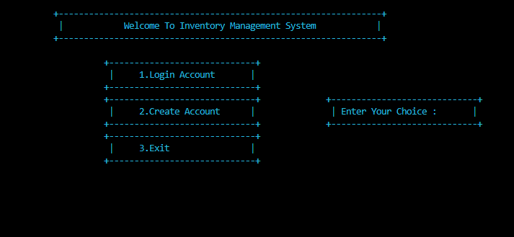
1.Login System
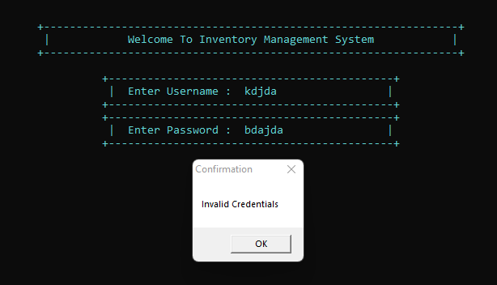

2.Loading Bar 3.Confirmation Message Box

4.Main Menu
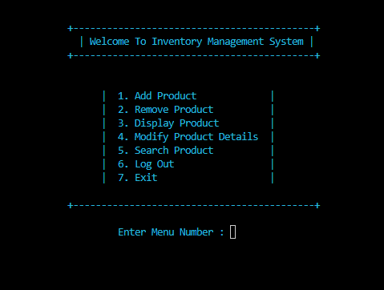

Conclusion:
In conclusion, an inventory management system written in C is a powerful tool for managing and organizing inventory data. This project report detailed the design and implementation of an inventory management system using the C programming language and various libraries. The system includes features such as file handling, product search and modification, product removal, confirmation messages and much more. Potential future enhancements include integrating the system with other business systems to provide a more comprehensive view, implementing real-time inventory tracking for accurate and timely decision making, developing a mobile application for on-the-go access, automating the ordering process for increased efficiency, adding advanced reporting capabilities for informed decision making, incorporating barcode scanning for efficient inventory tracking, hosting on the cloud for improved accessibility and scalability, and adding multi-language support for users speaking different languages.

